Aim: To create and deploy a virtual server on AWS Theory:
An Amazon Web Services (AWS) Virtual Machine (EC2) is a type of service offered by AWS that allows users to rent virtualized computing resources, such as virtual CPUs and memory, by the hour. These resources can be used to run a wide range of applications, including web servers, databases, and big data processing jobs.
Users have the ability to configure and customize the operating system, storage, and networking resources of their EC2 instances to meet the specific requirements of their applications. EC2 is one of the core services of AWS and is a part of the Elastic Compute Cloud (EC2) service.
Installation Steps:
- Create an AWS account
You can easily create an AWS account on the AWS Console. All new sign-ups get a free-tier offer.
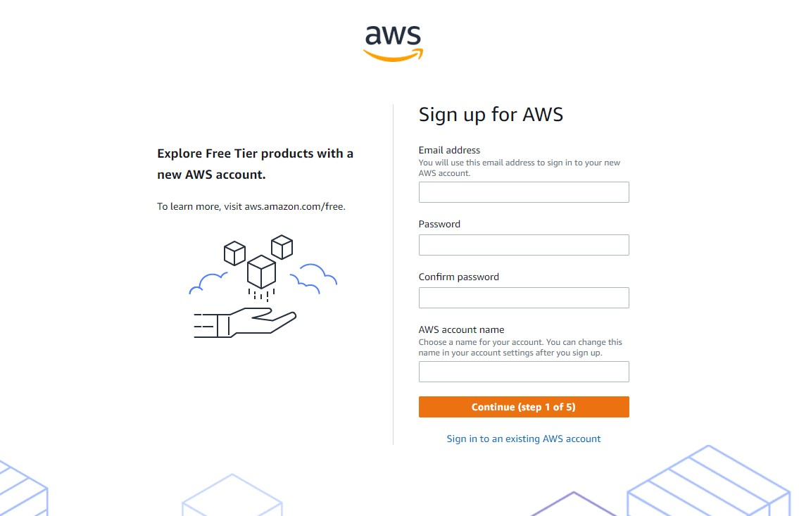
- Launch AWS virtual machine
Once you finish setting up your account, you can click on the AWS logo on the top left corner or search “console” on the search bar. You’ll find a number of options in the AWS console. Select “Launch a virtual machine” to get started with VMs. If you’re a new user, it can take up to 24 hours for your account to activate.
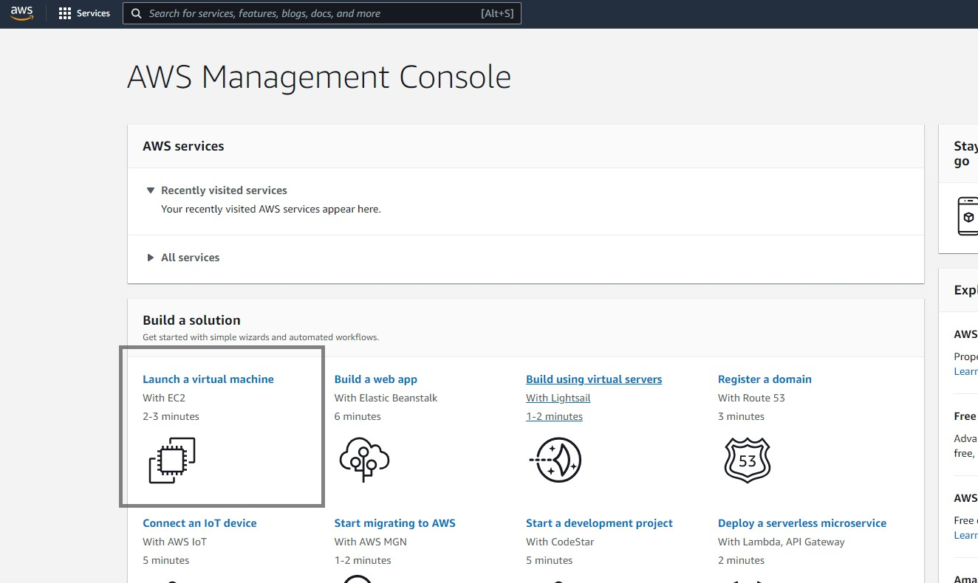
- Choose AMI
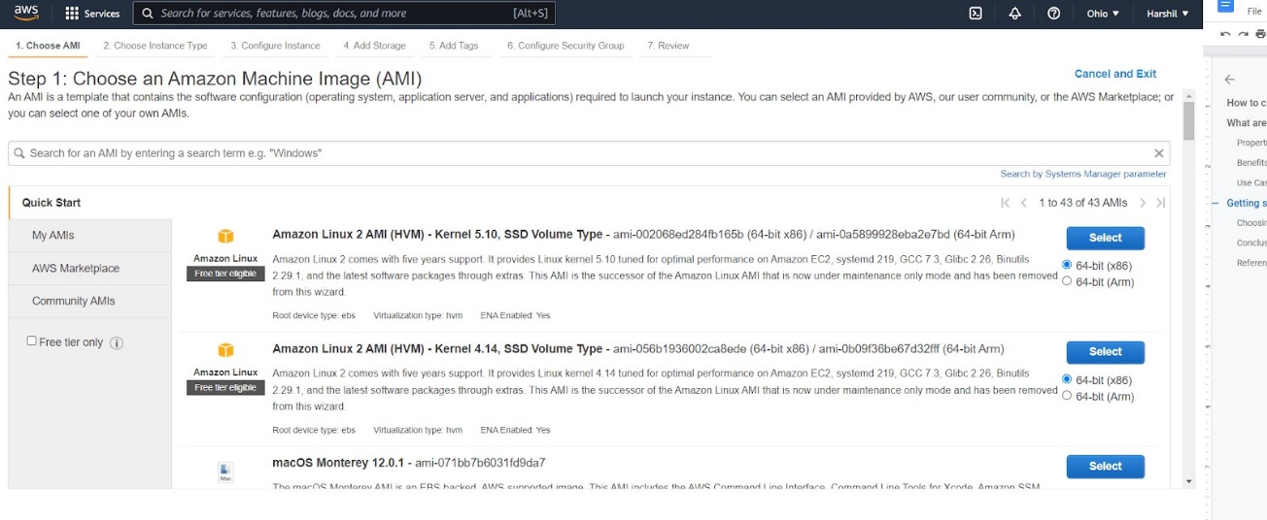
Amazon Machine Image (AMI) highlights the software setup (OS, application server, and apps). You can select Mac, Linux, or Windows OS. We’ll look at the setup for Windows virtual machines here.

- Choose and configure instance type
After choosing your operating system, you need to pick an instance type. Amazon EC2 offers many instance types tailored to specific use cases. An instance is a virtual server or virtual machine. They come in a variety of CPU, memory, storage, networking, and a lot more.
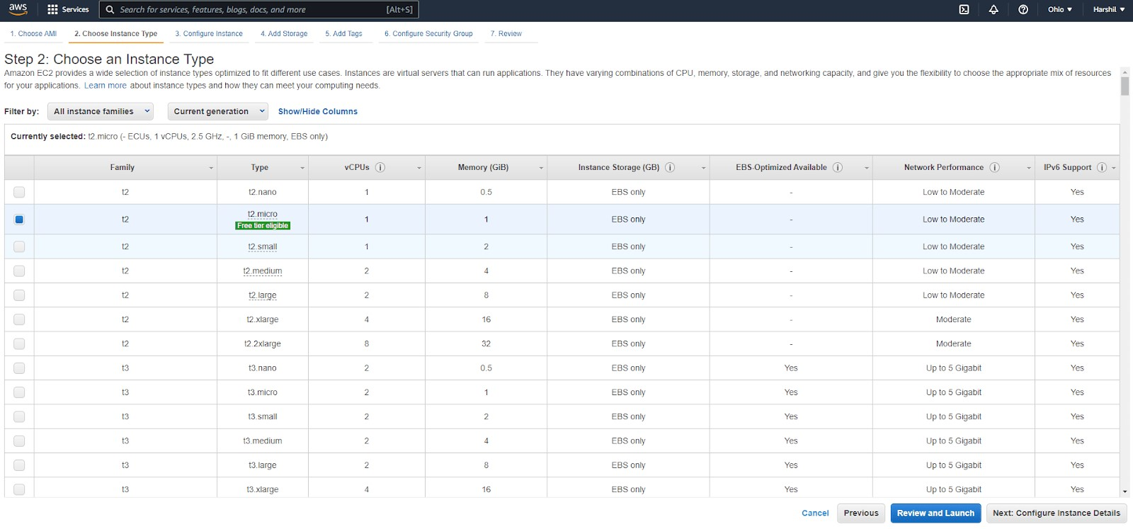
You can configure instance details, such as the number of instances, network, host type, and so on. Here, we’ll use one instance and keep the remaining details default.

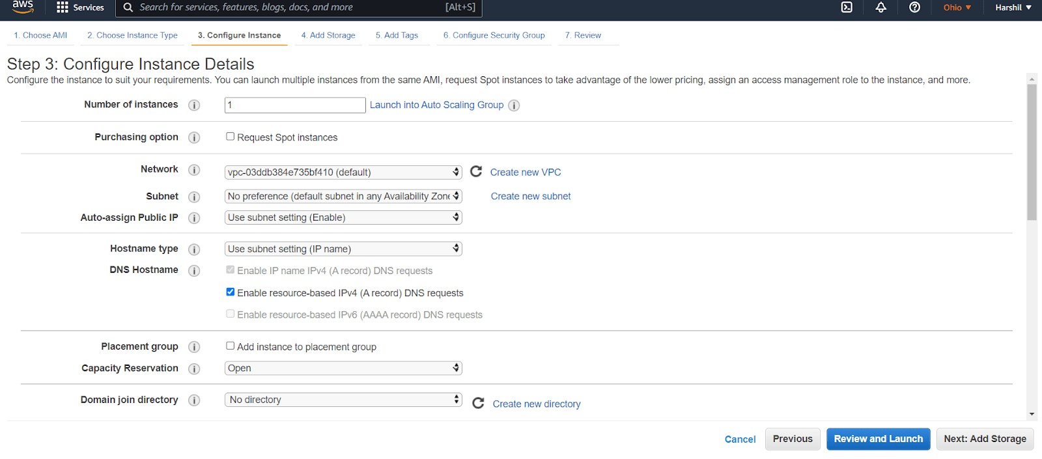

- Add storage and tags
Once you configure an instance type, you can add or update storage info. AWS allows you to add more EBS volumes and instance store volumes, as well as change the root volume’s parameters. Amazon Elastic Block Store (EBS) provides blockevel storage volumes for use with EC2 instances. It behaves like raw, unformatted block devices. You can mount these volumes as devices on your instances.
The next step is adding tags. A tag is a label applied to an AWS resource. Each tag has a key and an optional value, which users define.
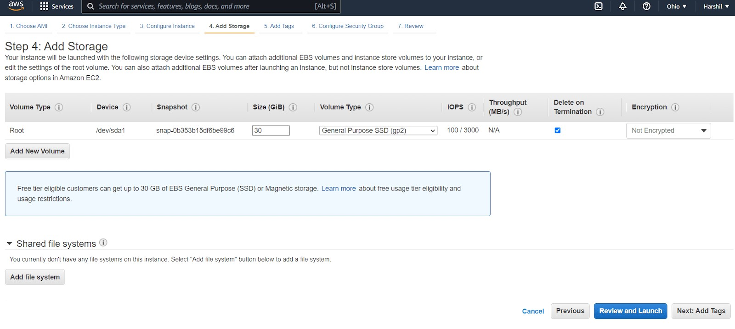
- Configure security
A security group is a set of firewall rules that control data entering and exiting your instance. You may either recreate it or pick an existing security group.
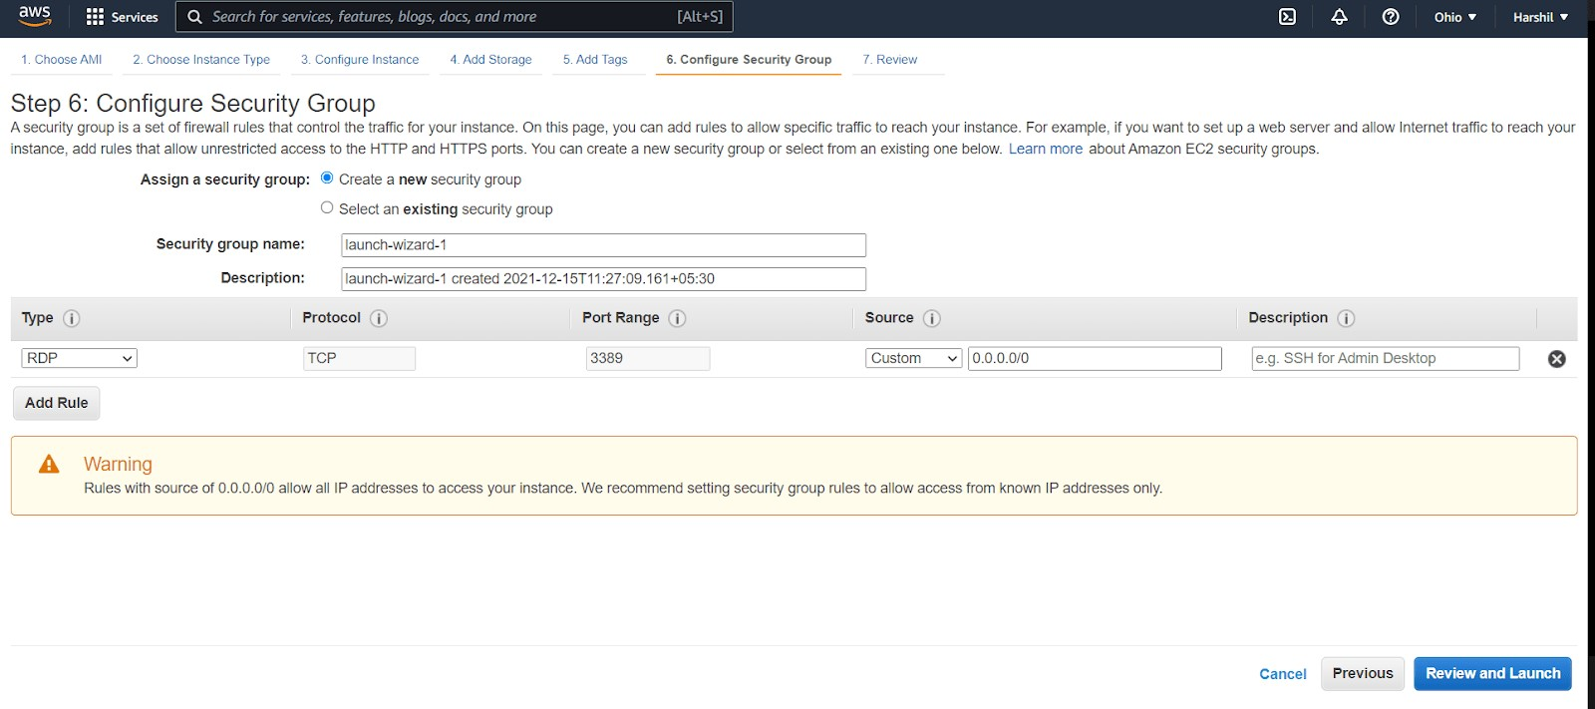
Security is a major concern when working on public clouds like AWS and Google Cloud Platform (GCP). Attackers can launch different attacks on public cloud deployments for lack of provider security. These attacks include DOS, DDOS, website defacement, and brute-force.
Public clouds have poor security, but with the right set of rules, they can be improved.
Public clouds offer limited customization. Clients can choose the operating system and size of the virtual machine.
Cloud data breaches are frequently caused by misconfigured cloud security settings. Many companies’ cloud security posture management solutions are insufficient for safeguarding their cloud-based infrastructure. 7. Review and launch your AWS virtual machine
The final step in creating an AWS virtual machine is to go through your instance details. Make sure every detail is correct, then click “Launch”.
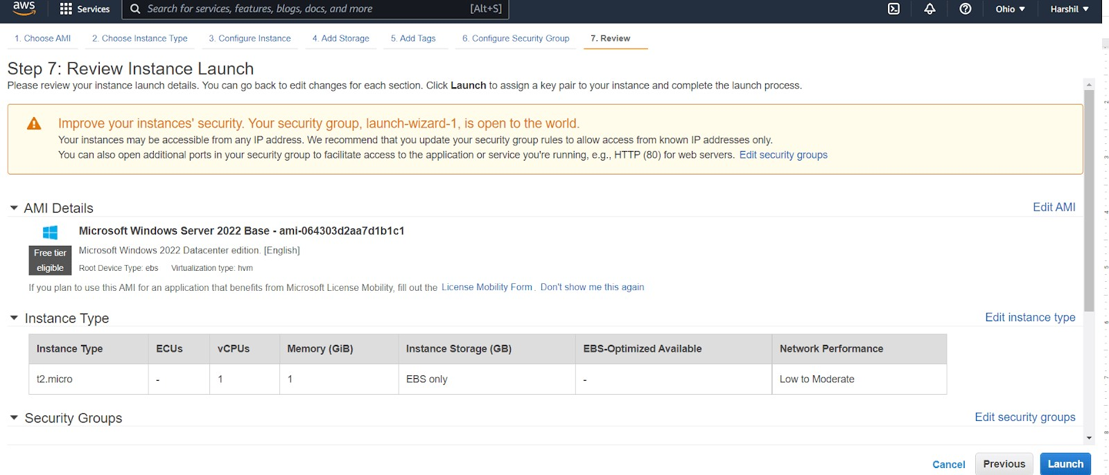
When you click “Launch,” you need to provide a key. To create a new key, select “Create a new key pair” from the drop-down menu and set a key name, for example, key task, keytest1, and so on. Make sure you download “key pair” before launching your instance.
A key pair is made up of a public key stored by AWS and your private key file. They work together to allow you to connect to your instance safely. You successfully created and launched a virtual machine on AWS. Now, check the launch status and connect to an instance.

8. Connect to an instance
After starting the instance, you can check the status using “Dashboard>Instances”.
Select your instance in the instance dashboard and click “Connect”.
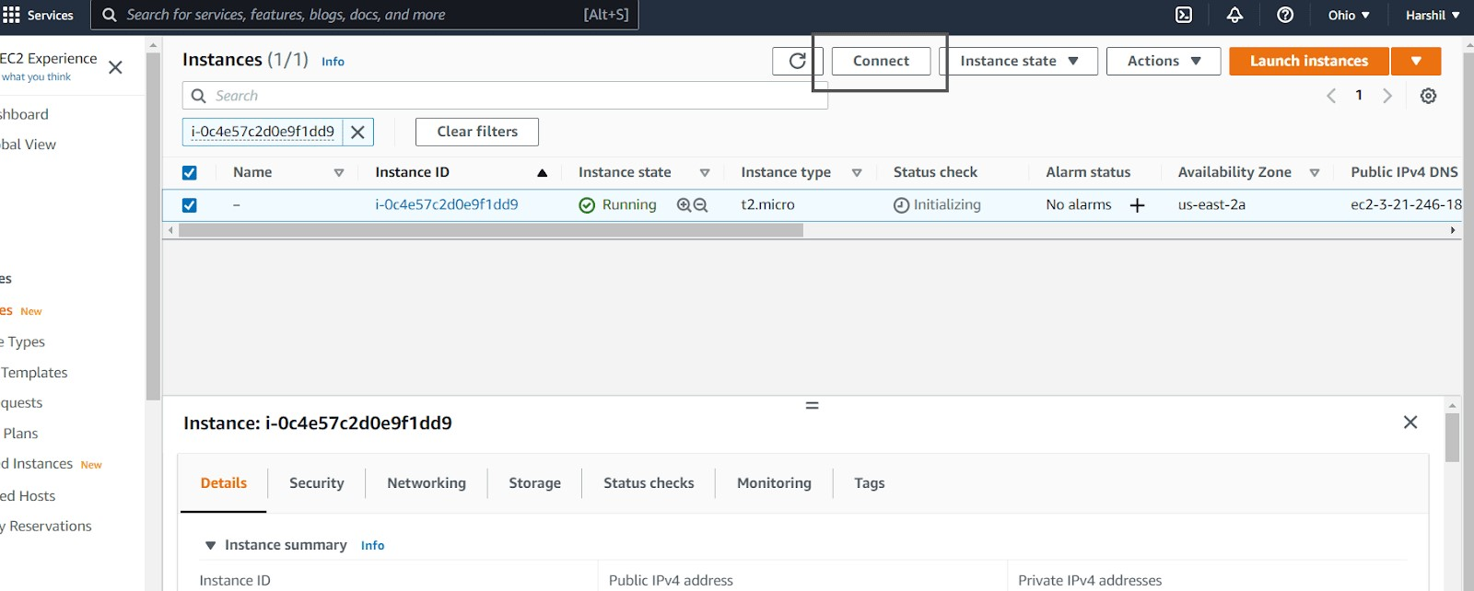

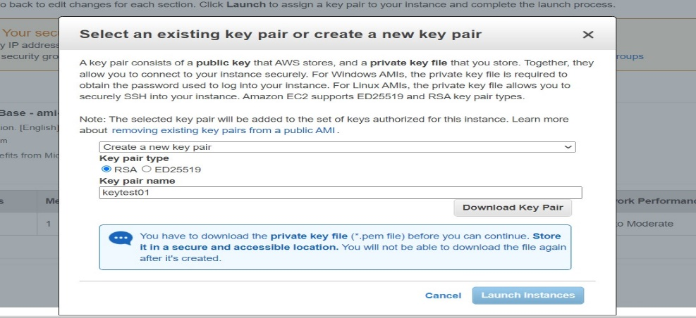
Select “RDP client,” click “Get password,” then upload the key pair downloaded when the instance launched (in step 7). After uploading the file, click “decrypt password” and download the remote desktop file.
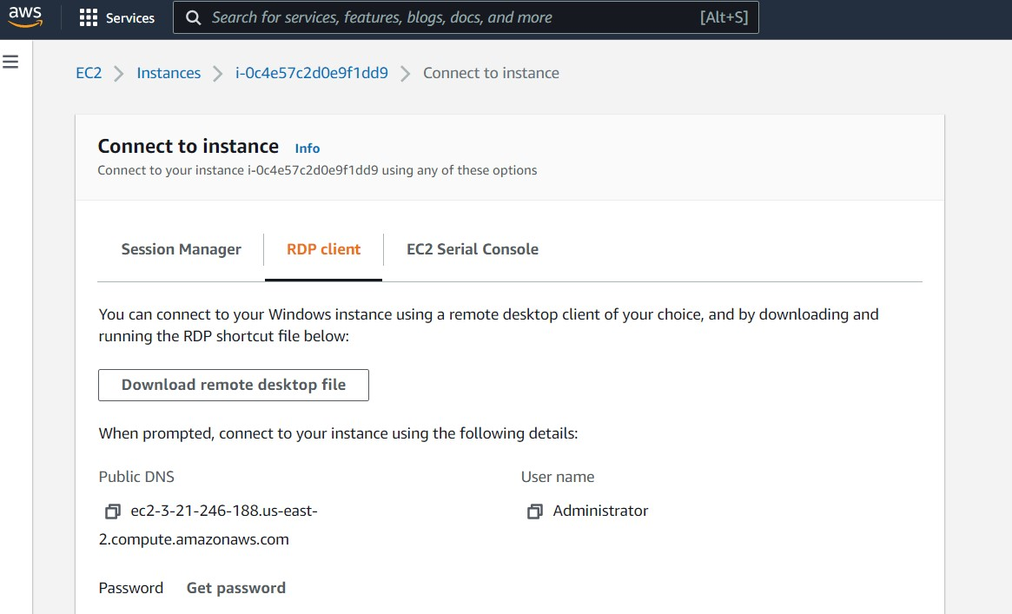
Open the downloaded file and enter your password.
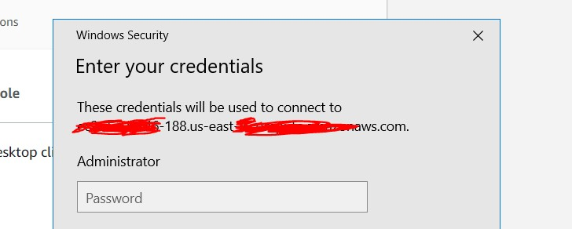

You should now see a screen similar to the one below, indicating that your AWS Windows virtual machine successfully launched!
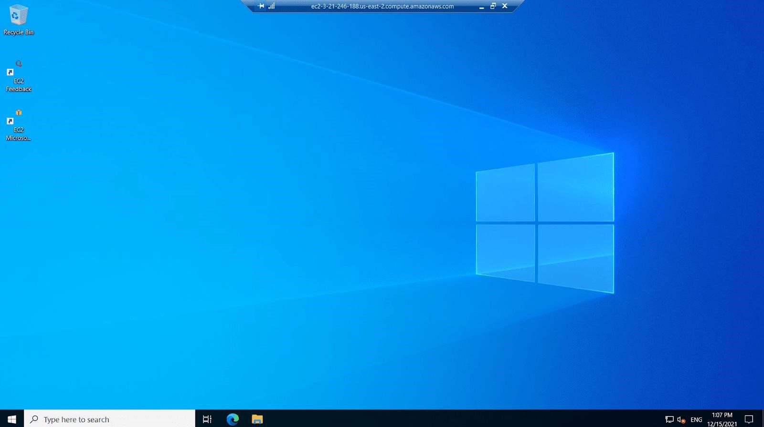

In this guide, we have explained the detailed process of creating a virtual machine (VM) on Amazon Web Services (AWS)
An Amazon Web Services (AWS) Virtual Machine (EC2) is a type of service offered by AWS that allows users to rent virtualized computing resources, such as virtual CPUs and memory, by the hour. These resources can be used to run a wide range of applications, including web servers, databases, and big data processing jobs.
Users have the ability to configure and customize the operating system, storage, and networking resources of their EC2 instances to meet the specific requirements of their applications. EC2 is one of the core services of AWS and is a part of the Elastic Compute Cloud (EC2) service.
Conclusion:

